Ideation Phase
Brainstorm & Idea Prioritization

Team ID | SWTID1745140705
Project Name | Shopez: E-Commerce Application
Maximum Marks | 4 Marks

Brainstorm & Idea Prioritization:
Step-1: Team Gathering, Collaboration and Select the Problem Statement
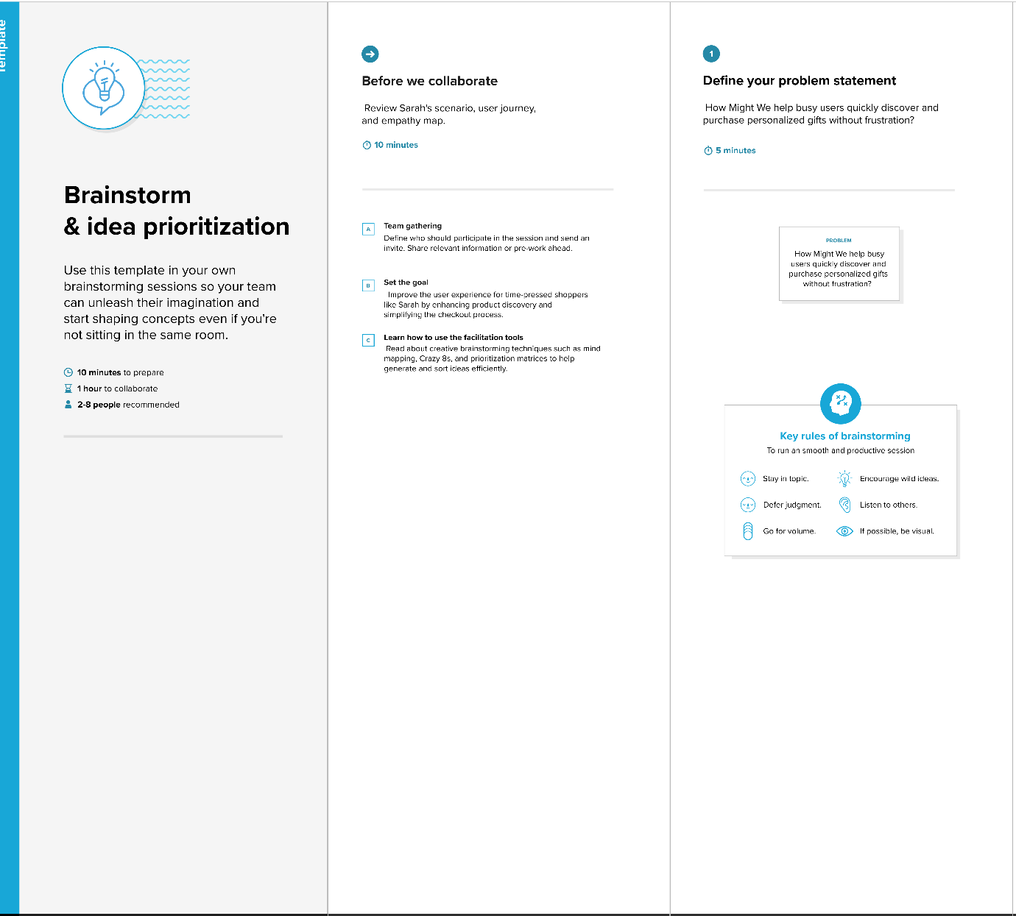

Step-2: Brainstorm, Idea Listing and Grouping
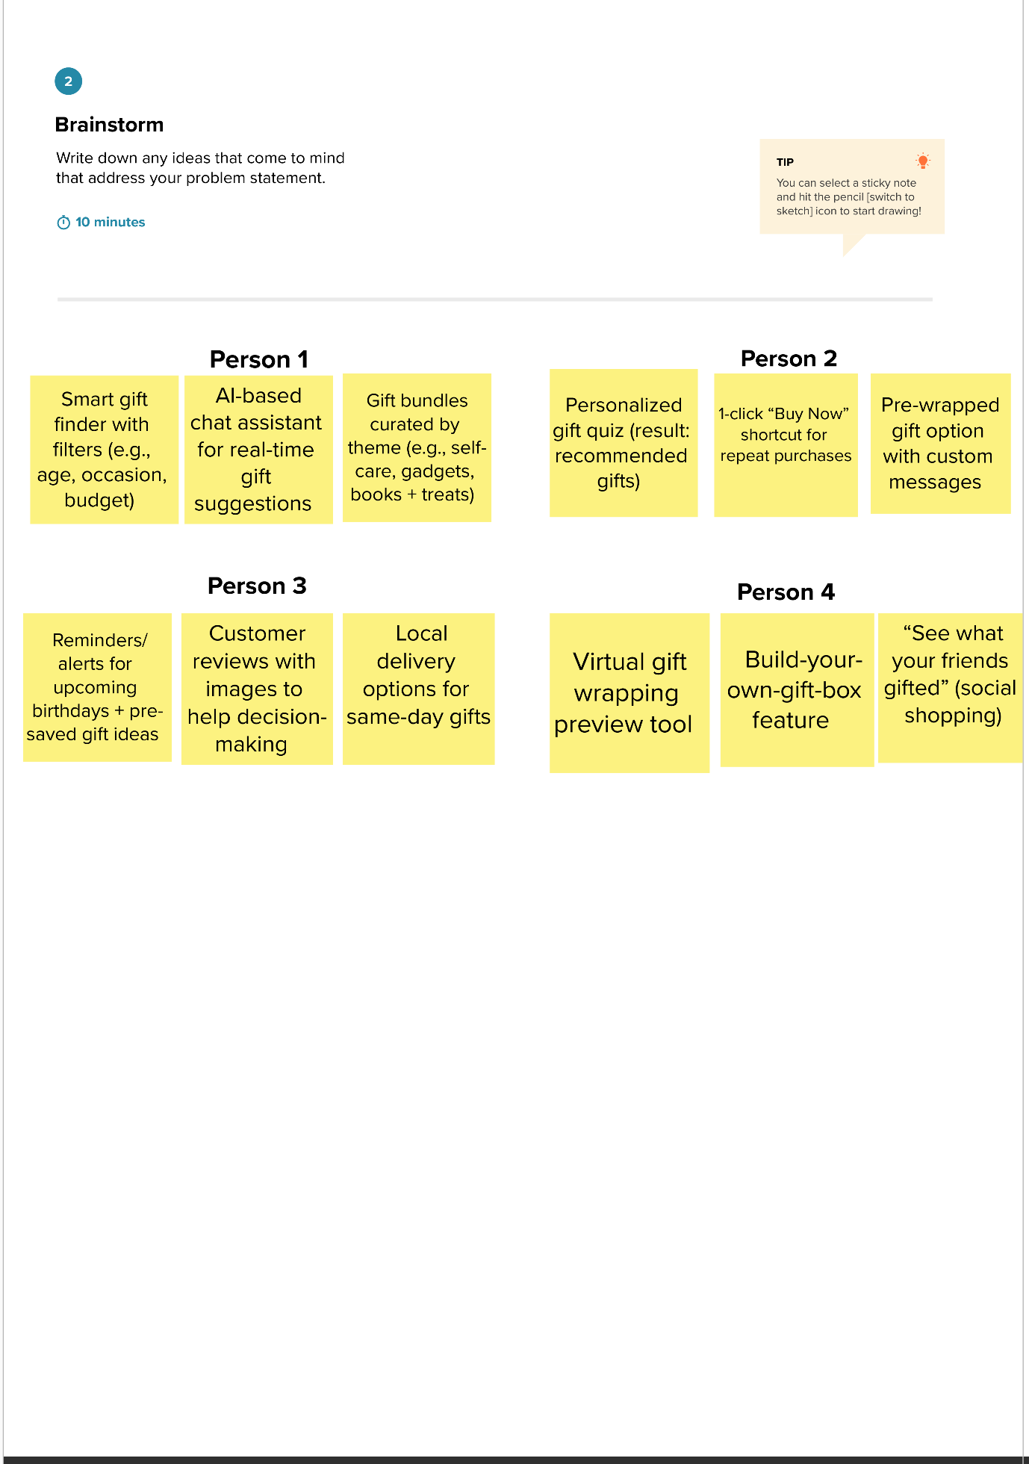

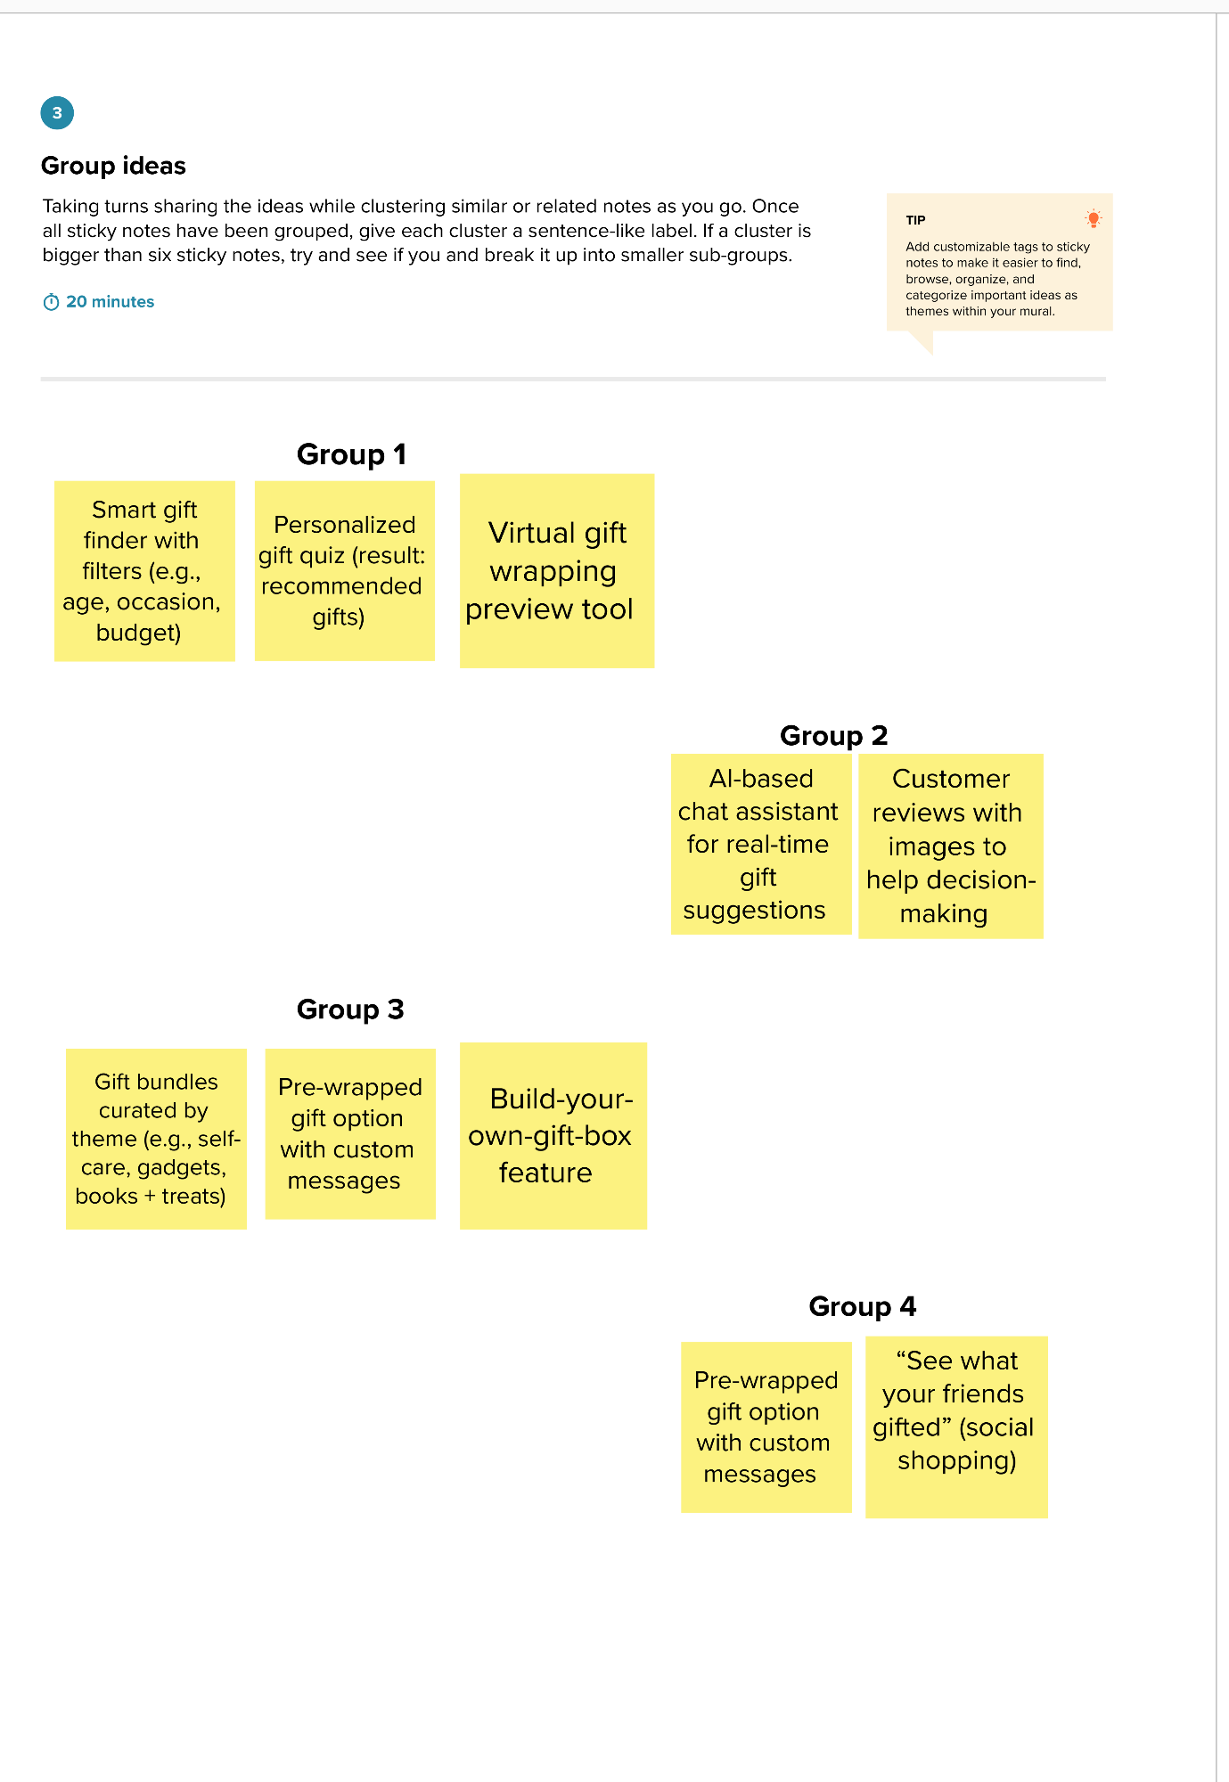

Step-3: Idea Prioritization
